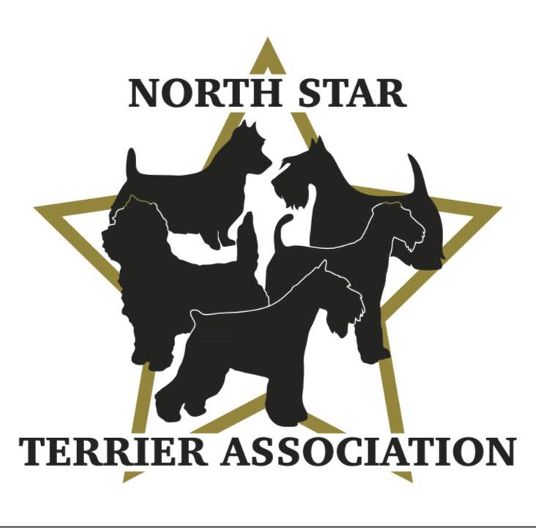

SPECIAL MEETING-TERRIER SPECIALTY NOTES
July 25, 2024, 7:00pm, Via Zoom
APPROVED:
The meeting was called to order by Vicki at 7:02pm.

ROLL CALL:
Member Attendees:
Vicki Barker, Donna Bonnicksen, Carol Dorris, Patty Patzman, Patty Reiman, Kari Ditty, Karla Edwards, Peggy Gerold, Margo Griffith, Danielle Hansen, Sara Mathies, Nikki Ollom, Dick Rueter, Lynette Spitzer, Erin Warshaw

OFFICERS REPORTS:

Secretary-Reading of 5/23/24 Minutes-members were asked to review the minutes on the NSTA website (also sent with email invitation to meeting) in lieu of reading them. No comments. Donna motioned to Accept, Kari 2nd. All Ayes. APPROVED.

Treasurer: Donna reported club has $8360 in checking account/cash on hand as of 6/30 (paid insurance for upcoming show). Next meeting will have more detailed information. No comments. Dick motioned to Accept, Kari 2nd. All Ayes.

TERRIER SPECIALTY:
Vicki began discussion:
- Start Time will be 9:00 am beginning with Sweeps, Juniors, Breed, Groups.
- Stewards-Vicki (Conformation) and Donna (Obedience Rally) have enough ring stewards (thanks to those who volunteered).
- Awards/Trophy Update:
  - Carol advised perpetual trophies, awards for breed (slip leads) and puppy winners (fur squeakers) are assembled in bags with club logo hang tag.
  - Beds for veterans will be completed once we have count of veterans entered (doing different sizes depending upon breed).
  - Donna will send a check to Carol for $690 (collected from sponsors) so she can put together winner’s envelopes. Credit cards from Amazon for juniors have been ordered for envelopes.
  - Patty R working on sign to display on trophy table acknowledging sponsors by category.
- Rosettes are being worked on by Brenda H. Carol will follow up to get photos to post on FB.
- Flat ribbons and sweeps envelopes from Onofrio need to be picked up the morning (early) of the show.

- Judges Gifts ($20 allocated per gift):
  - Brenda U is donating wine for the gifts.
  - Vicki will get MN themed items and pick up bags to assemble everything in.
- Set Up and Take Down being overseen by Brenda U and Larry.
  - The night before, they will hang the club banner and make sure the table from SCVKC is set up along with table being provided by Brenda H ringside.
  - The next morning (for the tables):
    - Carol will bring trophies and awards, buckets of candy, hand sanitizer, and judges care kits for Conformation and Obedience/Rally tables.
    - Patty R will bring table/tablecloth to set up by ring for membership applications and fund-raising items.
    - Brenda H will bring black and white tablecloths, Vicki will bring red logo tablecloth.
    - Diane will bring flowers.
    - Vicki will bring coolers with water & soda and cleaning supplies (Carol will bring paper towels).
    - Donna will bring applications.
  - Set up will begin at 7:00am-requesting help from all members there.
  - Take down will occur after Terrier Group is over and would appreciate help from all members there.
- Hospitality:
  - Patty P confirmed Location will be alongside her motor home (same as last year).
  - Airedale club will participate and will provide items to use in set up and will share in expenses for food.
  - Working on a lot of signage to improve visibility, better advertise, and draw more people in.
  - Will need volunteers for set up Thursday, coverage on Thursday (8:00am-4:00pm-2hour shifts preferable) and Friday (8:00am-2:00pm-2hour shifts preferable) and take down Friday. Margo will create a sign-up form to send to members (will send to Patty P and Carol for sign off). Need to decide how to send to members (email, FB?)
  - Will have club applications for NSTA and other terrier clubs in the tent (Patty P will work with clubs to get these).
- Future Judges Confirmed-Karen Wilson 2025 and Roz Kramer 2027 Conformation. Brenda H NOHS 2025.

STATE FAIR:
- Club scheduled 8/31/24-8:00am – 8:00pm.
- Shifts will be:
  - Brenda U, Larry – set up 8:00am-12:00pm.
  - Danielle, Karla & Nikki-12:00pm-4:00pm.
  - Diane, Dick-4:00pm-8:00pm with take down.
- Each group will bring information about breeds being presented for booth
- Danielle will work with MPDBA FB Group who are looking for pictures and info on terrier breeds being shown.

MEMBERSHIP APPLICATIONS:

2nd Reading:
- Sarah Class-Nowthen, MN, American Staffordshire Terriers-Sponsored by Brenda H and Donna. Danielle motioned to accept as new member, Patty R 2nd. All Ayes.
CONGRATULATIONS and WELCOME TO THE CLUB SARAH!

PERFORMANCE:
Erin provided the group with a detailed presentation on the Tracking:
- Provided us with information from the AKC website about Tracking and its history, eligibility, how to get started and the levels that can be achieved.
- Discussed what equipment is needed, the steps involved and how to train along with her own personal experiences.
- Shared an extensive video from Cyndi Olson showing her and her dog in action.
- Classes for this sport are offered at TCOTC.
- Discussed doing an in-person event where a group could do a demonstration (i.e., MN Search and Rescue, Retrievers, Group, possibilities.).
- Members truly enjoyed the presentation, many expressed they would love to try it, and thanked Erin for doing such a fabulous presentation!
- Erin will post the presentation on our FB page.
- Her next presentation will be during our 9/26 Members Meeting-can’t wait to see what it will be about.

Meeting Adjourned 8:10pm (Donna 1st, Carol 2nd)

