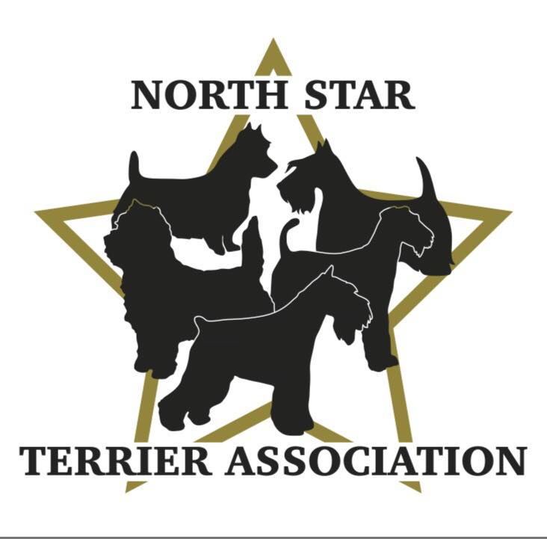

GENERAL MEETING NOTES
JANUARY 26TH, 2023, 7:00pm, via ZOOM

MINUTES PENDING APPROVAL:

The meeting was called to order by Diane Schlicht at 7:10pm.

ROLL CALL:

Member Attendees:
Vicki Barker, Donna Bonnicksen, Kari Ditty, Carol Dorris, Doug Dunn, Peggy Gerold, Larry Lemke, Sarah Mathies
Sue Osborne, Patty Patzman, Duane Pulford, Patty Reiman, Dick Rueter, Diane Schlicht, Brenda Ugoretz

Member Applicants/Guests:
Sylvia Mills

***A quorum was needed tonight which we have.

OFFICERS REPORTS:

Reading of Minutes-minutes of previous meeting not available to read.

President Report-nothing to report for this meeting.

Secretary Report-joined late so no report available.

Treasurer Report-read and approved.

COMMITTEE REPORTS:

Nominating Committee-Diane raised this as first order of business. Peggy read the slate proposed for officers and directors for 2023. It is as follows:
- Vicki Barker-President
- Patty Patzman-Vice President
- Carol Dorris-Secretary
- Donna Bonnicksen-Treasurer
- Brenda Holman-Director
- Sue Osborne-Director
- Patty Reiman-Director
No additional names were proposed at the November meeting so above slate was voted on. Larry made a motion to accept the new slate of electors, 2nd by Patty R. All voted yay, no nays. New board established. CONGRATULATIONS TO ALL!
Vicki welcomed new board members. Those new to the board, introduced themselves, discussed their “dog history” and shared their goals for the club as well as their desire to help support and maintain the integrity of terriers and educate people how great terriers are.

NEW MEMBERSHIP APPLICATIONS:

Applications-Vicki requested the reading of new membership applications.

2nd Reading-Donna read application for Steven Schellenberg (Kerry Blue Terriers-from St. Paul). Patty P. and Kari recommended him. Vicki requested a vote to approve membership. Donna made a motion to vote to approve their membership, 2nd by Larry. All voted yay, no nays. Membership approved. WELCOME TO THE CLUB STEVEN!

2nd Reading-Donna read application for Jennifer Stevenson (Scottish Terriers-from New Hope). Patty R. and Peggy recommended her. Donna made a motion to vote to approve their membership, 2nd by Larry. All voted yay, no nays. Membership approved. WELCOME TO THE CLUB JENNIFER!

1st Reading-Vicki Barker introduced Sylvia Mills who joined us this evening for the first meeting who told us about herself and her history with terriers for over 40 years. Donna read application for Sylvia (Wire Fox Terriers-Marine on St. Croix). Second reading will be done during the March General Meeting.

1st Reading-Donna read application for Beret Walsh (Staffordshire Bull Terriers-Minneapolis). Virginia and Vicki recommended her. Second reading will be done during the March General Meeting.

NEW BUSINESS/GENERAL DISCUSSIONS:

Future Club Meetings-Vicki brought up starting back up with in person meetings. Suggested could set up meetings so they could be virtual as well for people who still did not want to meet in person or are too far to travel to the location of the meeting. Donna suggested Perkins, where meetings had been held before but there were concerns about the noise and distractions from the restaurant. Sue suggested looking into libraries and Byerly’s that have conference rooms/areas that are free to use (other suggestions would cost to use which is not the first choice). Both options (Byerly’s and libraries) had a favorable response from members because of the ability to use different locations (due to distance concerns from members). It might require starting meetings earlier due to closing concerns. Donna volunteered to investigate using conference rooms at Byerly’s and Sue volunteered to investigate using libraries. Both will try to have proposals before the next meeting as there may be a desire to start up right away.

2nd Specialty in January (during LOL show)-Vicki asked members their thoughts about adding a second specialty in January during the LOL Dog Show. Overall response was positive. Specialties ran on both Thursday and Friday in 2022 so we would need to find out what day we would be able to participate if we decide to move ahead. For 2023, Chicago will not run their show concurrently like they did in 2022 which is a positive (LOL had 89 terrier entries vs. Chicago’s 124 terrier entries). Biggest questions-would these additional terrier people come to LOL if there was a specialty making it worth running? Would the January weather in MN be a concern to people not local? Patty R. asked about Cambridge, but Vicki said it is too close to SCVKC show which we will be part of for 2023. The positive to participating is we will get money back from the show to help build our treasury which is important since the club has not been able to do a lot of fund-raising events over the past few years. Members felt positive about exploring this opportunity. All agreed that Vicki should gather more information for further discussions.

Fundraising Events-Vicki brought up the need to work on more fundraising events to help build our club funds. The following options were discussed.

- B-Match (Saturday)-Vicki discussed the match run by the club in 2022 which had not been very successful, but she felt it was primarily because it was not promoted enough to draw people to it. If we do again, we will need to plan further out and promote early and A LOT. Donna will investigate Bloomington venue to run the event which is a location the club felt was more centralized making it more convenient for most to get to plus the price was right compared to others to rent. Other suggested venues were Animal Inn in Lake Elmo by Patty R., and Tails We win in Burnsville by Sue which Sue will investigate. If club moves ahead, would do conformation and rally for puppies and adults. It would require sending an application to the AKC.

- Basket Raffle-Peggy suggested at the match, we do a basket raffle which was successful at the Bloomington Club Event. People donate items to make several baskets. The key would be to advertise to build interest. Duane advised that in the state of MN, this falls under the gambling category and paperwork would need to be sent to the state ahead of the raffle which takes time and can be a hassle. Since this is a small event, it could fall under the radar, but we need to agree we would want to take the chance. Peggy suggested possibly doing as a silent auction which would not fall under the gambling category. This was left open for now, we will revisit.

- Grooming/Handling Seminar-Sue brought up possibility of doing a grooming seminar. Vicki had done several of them which were successful and huge money makers. Her suggestion was to use local talent which would be more cost effective and find a centralized well priced facility to rent (Bloomington was suggested due to centralized location and relatively low cost to rent). Vicki talked about one of the seminars she did with Patty R.’s Herbie where they groomed in the morning and did a handling class in the afternoon which might be a good format to follow. Patty P. suggested promoting not only to dog show people but to grooming shops as well. In addition to Vicki, Duane suggested Anna Hawks, Sue suggested Susan Hatch and Patty R. suggested Lynette Spitzer as all possible groomers to handle the classes. The group felt very positive about this type of event. Patty P., Patty R. and Carol will work on a few proposals and present them at the February 23rd Board Meeting. If details can be worked out, this would be the event of choice.

Vicki discussed the August Specialty and said we have time to discuss at our March 23rd Meeting where we will work on promoting the event.

Brags were shared.

Donna motioned to adjourn meeting at 8:25pm, Patty P. 2nd.

