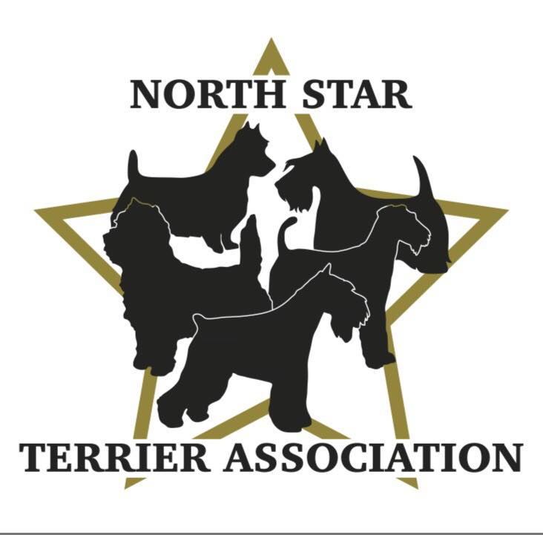

GENERAL MEETING NOTES
JUNE 1st, 2023, 7:00pm, Via Zoom

MINUTES PENDING APPROVAL:
The meeting was called to order by Vicki Barker at 7:05pm.

ROLL CALL:

Member Attendees:
Vicki Barker, Laura Becker, Donna Bonnicksen, Carol Dorris, Peggy Gerold, Sue Osborne, Patty Patzman, Patty Reiman, Dick Rueter, Erin Warshaw

OFFICERS REPORTS:

Reading of 3/23/23 Minutes-members were asked to review the minutes on the NSTA website in lieu of reading them. If there are no comments, then they will be approved.

President Report-Vicki confirmed the AKC has approved our application for the August 24th Terrier Specialty at Lake Elmo Fairgrounds.

Secretary Report-no updates for this meeting.

Treasurer Report-no updates for this meeting.

OLD BUSINESS:

Grooming/Handling/Sparring Clinic-June 10th at BOTC:
- Carol reviewed the number of people signed up by Event-17-grooming, 9-handling, 8-sparring, 4- ½ day audits.
- Carol will send an email on the Wednesday before the event reminding participants what to bring along with other details.
- Vicki will bring Emily and Lynette will bring Nikki to assist them.
- Opening: Donna will make sure she is there by 8:00 along with other members to open the door of the facility to greet and direct people where to go to watch/set up.
- Parking: Donna will make sure parking on the west side of the building is approved for the day. Craig will help to direct people where to park.
- Set Up:
  - Grooming-tables should be set up approximately 6ft apart using the entire room allowing the instructors to easily walk around as they give one on one demonstrations and information.
  - Handling/Sparring-area to use will be set by Vicki and Lynette.
- Member Responsibilities:
  - Vicki will bring prepared name tags, applications, checks.
  - Patty P will bring a water cooler, water, and shop vac.
  - Donna will pre-order lunch from Davanni’s (for up to 20 people)-Craig will pick up around 11:30.
  - Carol will bring the final list of attendees and what they signed up for, payment status (who will bring payment with them), paper cups, breakfast bars, chips, plastic bags to collect hair.
  - Dick will bring cookies.
- Vicki and Lynette will do introductions and outline the day’s schedule and how the clinics will work.
- Pictures of Event-everyone should take pictures throughout day to post on FB.
- Clean Up-everyone to pitch in.

Terrier Specialty-August 24th at Lake Elmo Fairgrounds (part of SCVKC Show):
Trophies, Prizes and Gifts:
- Perpetual Trophies-Carol advised may need to come up with alternative due to shipping issues-will keep everyone updated. Still need winners for BIS and Puppy for last 3 events. Winners of Veterans confirmed.
- Trophies for breed winners (25) still need to be finalized since previous suggestions have not worked out. Erin suggested a tote bag with a logo which everyone thought was a great idea. She and Carol will research options to present to BOD by the end of month. Allocated $ to be determined.
- Hand Towels for breed winners, purple, blue, and red embroidered, are covered (last few being embroidered).
- Hand Towels for NOHS, white with colored embroidery reflecting placement, are covered (being embroidered).
- Lamb Chop toys for Puppy winners are in hand.
- Plaques for winners of BIS, Veterans and Puppy, need to be ordered. Allocated $60.
- Ribbons and rosettes are ordered for all events.
- Tug toys for Obedience winners are made and done.
- Buckets with club logo stickers will be given to Junior Handler winners.
- Judge’s gifts (4) will have a Minnesota theme (chocolate, wild rice, etc.). Allocated $80.
Hospitality:
- Patty P will oversee the setup of the Pop-Up Tent outside (across from the ring). Will be open to all.
- Will offer water from a cooler, coffee from a pot, and assorted individually wrapped snacks. Allocated $150.
- Patty R will make signs letting people know about the Hospitality area-one to display on easel on road and another to hang on tent.
- Make sure applications for club are on the table in the tent.
Set Up/Clean Up:
Need to follow up with Brenda U and Larry L.
- Miscellaneous:
  - Follow up with Diane S about flowers for table.
  - Follow up with Brenda to get the NSTA banner.

Note Cards:
Carol ordered 50 cards and envelopes with the club logo which should be in within the next 2 weeks-$125 plus tax.

Logo Stickers:
Patty P can buy 100-2” stickers (logo all black) for $32 plus tax which was approved.

Facebook:
Leave as public for now. Admins (Carol, Theresa, Brenda U) need to monitor what is posted.

Website:
Discuss extending PayPal coverage during the next BOD meeting.

Breeder Referral Form:
Will not have a listing included on the NSTA website. If we receive inquiries, we will refer to the clubs.

State Fair:
Plan is to have a booth but need to discuss more at next BOD & Members Meetings.

Miscellaneous:
- Canine Influenza is in the twin cities so be careful. Shots are hard to find.
- Scam Emails-BEWARE!!!
- Future Meetings-unanimous agreement to have all meetings via Zoom.

NEW MEMBERSHIP APPLICATIONS:

Applications-Vicki requested the reading of new membership applications.

2nd Reading-Donna read application for Cindi Bell (Scottish Terriers-Pine City MN). Patty R. and Carol recommended her. Donna made a motion to approve membership, Patty P 2nd. All yays, no nays. WELCOME TO THE CLUB CINDI!

2nd Reading-Donna read application for Laura Becker (Scottish Terriers-Deer Park WI). Patty R. and Carol recommended her. Donna made a motion to approve membership, Patty P 2nd. All yays, no nays. WELCOME TO THE CLUB LAURA!

1st Reading-Donna read application for Margo Griffith (Kerry Blue Terriers-Rochester MN). Dick and Donna will sponsor her. The 2nd reading will be done during the July Members Meeting.

Meeting adjourned at 9:00pm.

