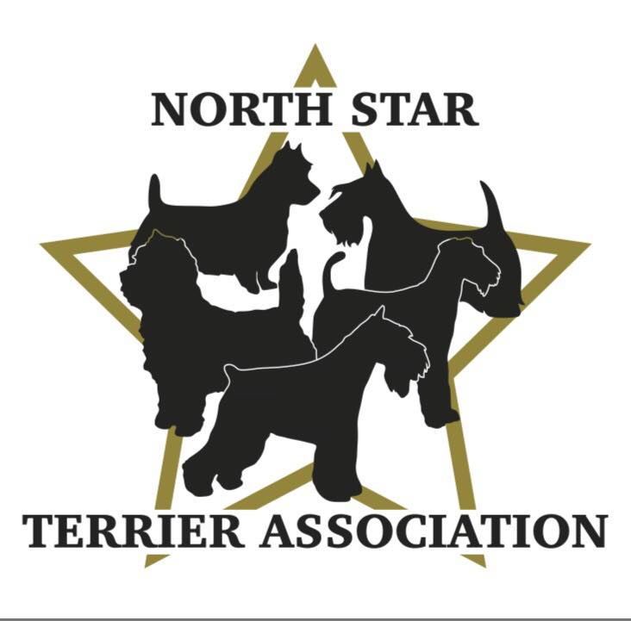

**GENERAL MEMBERSHIP MEETING**

**SEPTEMBER 26, 2024, 7:00pm, Via Zoom**

**MINUTES PENDING APPROVAL:**

The meeting was called to order by Vicki at 7:05pm.

**ROLL CALL:**

**Member Attendees:**

Vicki Barker, Donna Bonnicksen, Carol Dorris, Patty Patzman, Brenda Holmen, Patty Reiman, Brenda Ugoretz, Debra Crane, Kari Ditty, Karla Edwards, Larry Lemke, Margo Griffith, Danielle Hansen, Nikki Ollom, Lynette Spitzer,

**OFFICERS REPORTS:**

**Secretary-Reading of 7/25/24 Minutes**-members were asked to review the minutes on the NSTA website (also sent with email invitation to meeting) in lieu of reading them. One correction noted by Lynette to correct September meeting date listed from 9/25 to 9/26. Will be done and reposted to website. No other comments. Patty P motioned to Accept, Lynette 2nd. All Ayes. APPROVED.

**Treasurer:** Donna reported club has $7285.23 in checking account/cash on hand as of 8/31. This amount does not include income from show ($600.00 for fund raising, $69.50 of awards not used and $175.00 for new memberships) or expenses ($397.50 for rosettes). It also does not include gross profit payment from SCVKC which we are still waiting to hear on. As a reference, the club account on 8/31/23 was at $6554.69 and for 2023, the club received payment of $1247.71 from SCVKC). Carol motioned to Accept, Patty P 2nd. All Ayes.

**TERRIER SPECIALTY RECAP:**

**PROS:**

* Hospitality Tent-people appreciated the club offering snacks, coffee, and other beverages throughout the day. It provided a comfortable area to sit and chat. People liked the use of the paw prints to lead them to the tent.
* Fund Raising Tent-the tent was filled all day and became a place for people to come and talk. People had a good time spinning the wheel and answering questions for prizes. Kids enjoyed the sheets and crayons offered for coloring. The response was positive to the items being sold/auctioned-raised a total of $600 for the club. Signed up 5 new members.
* Reviews from the judges were very positive. The stewarding and ring management kept things running smoothly and on time (thank you Vicki, Dick, Diane, and Marilynn). David Alexander was thrilled to have been invited to judge (“coming home to terriers”). All the judges loved our MN themed gift.
* Participants were very positive about the prizes, cash awards and rosettes offered (do not change anything but build upon this for future shows as “formula” works).
* People loved the trophies.
* Transport for David Alexander was appreciated by him and the club (thank you Brenda U).

**CONS:**

* Hospitality Tent-not covered later in the day, food drawers and coffee were empty later in the day.
* Trophies-negative comments about not having a perpetual trophy for Juniors and NOHS.

**IDEAS FOR 2025:**

* Two Day Show-a number of members/participants suggested running the Specialty on Thursday and a regular Terrier Show on Friday to bring more people in (Friday being an open day for many of the terrier breeds is a negative from a time and cost standpoint). There are concerns about scheduling which Lynette and Danielle volunteered to discuss with Judy C at SCVKC.
  + If we move ahead, will also need to speak to David S at SCVKC about judges already there that could judge for our club. Karen Wilson is set for judging Thursday Breed & Group (Brenda U asked to send info to Dave S at SCVKC until new Chair is nominated. Brenda H will judge NOHS. Need a Sweeps/Junior Judge-someone local.
  + Need to finalize Show Chair.
* Add Perpetual Trophies for Juniors and NOHS. Carol will check with supplier to see if same trophies are available and what the cost is. She will present information at next BOD meeting. If we move ahead, Brenda H and Danielle offered to look up past winners (before 2023) as there are no club records.
* Add 4-6 Puppy Event. Need to clarify what’s involved. Brenda H volunteered to judge. She will be at Hutchinson where they are running this and will gather info about what’s involved to run this to discuss at next BOD meeting. If we move ahead, will need to assign someone to run.
* It will be the clubs 5 Year Anniversary. Look at ways to highlight and promote.

**STATE FAIR:**

* Thank you, Brenda U, Larry, Danielle, Karla, Nikki, Diane, Dick for representing our club!
* Our team felt it was a very well-run event. It was easy in/out/set up, good air flow, secure for dogs and personal items.
* It was a fun day, and spectators loved meeting and learning about the terrier breeds being shown. Our team loved the opportunity to share their knowledge, and the dogs seemed to love the attention until it wore them out.
* Would like to do this again next year noting the following:
  + Look to see if we can do 2 different days.
  + Create Breed information sheets to hand out to people.
  + Create trading cards (people were looking for these-some clubs were already handing these out).
  + Used digital picture frames on each end of booth so people could see highlights about the dogs there while waiting on line to meet them. Next year, look into bringing a small TV as well to show videos.

**NEW BUSINESS:**

* Juniors are the future. Club needs to explore ways to get juniors to join (i.e., sponsorship).
* Explore ways to reach out to and draw in new members from local breed clubs

**MEMBERSHIP APPLICATIONS:**

**1st Reading:**

* Tara Burr & Ava Rawlings-St. Francis, MN, Breed: Miniature Schnauzers
* Debra Crane-Eden Prairie, MN -Breed: Cairn Terriers
* Bill & Liz Morice-Rochester, MN -Breed: Norwich Terriers
* Stephanie Sorensen-Eleva, WI -Breed: Border Terriers
* Jeri Stempniewski-Excelsior, MN -Breed: Soft Fox Terriers
* Camille Connelly-Chaska, MN -Breed: Norwich Terriers

Meeting Adjourned 8:15pm (Kari 1st, Brenda U 2nd)